**Report week 6**

7.5

Confirm the process doesn't end even if the controlling terminal is cut.

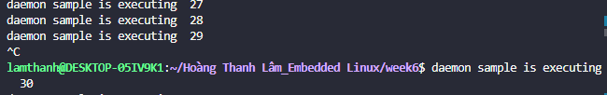

Confirm the process can be ended by the kill command

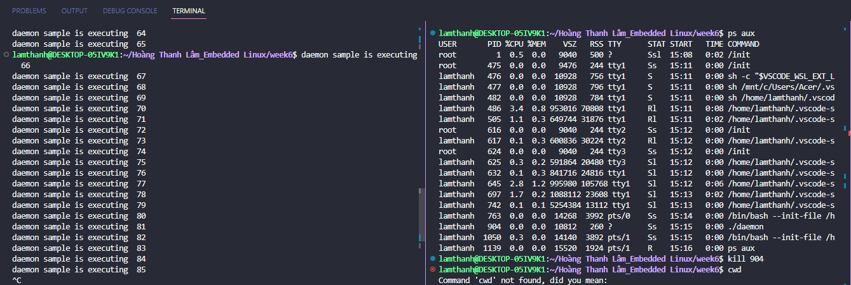

The first argument 1 in the sample program specifies that the daemon should be created in the background, but does not change the current working directory. If you modify the first argument to a different value, such as 0, the daemon process should change its current working directory to root :

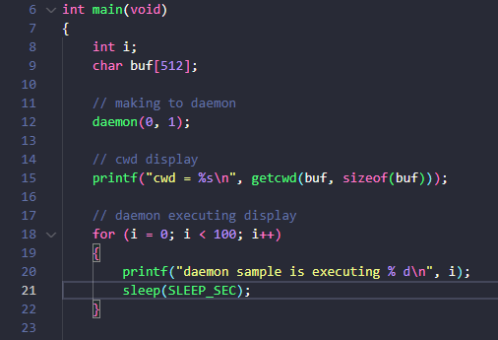

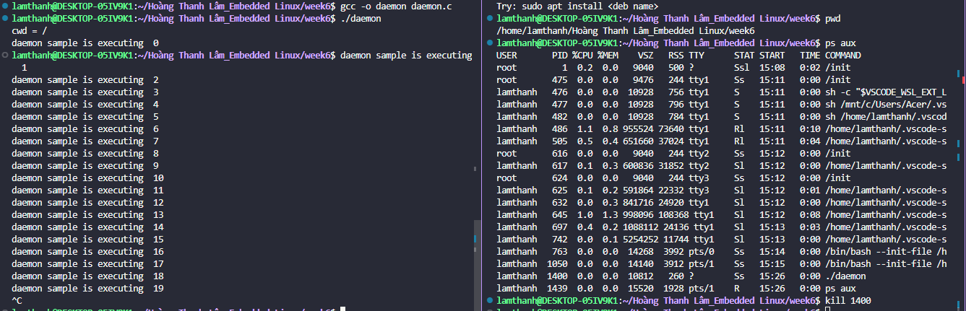

The second argument 1 in the sample program specifies that standard input, output, and error should not be redirected to /dev/null, so the output messages from the daemon process will be displayed on the terminal where the program was launched. If you modify the second argument to 0, the output messages from the daemon process will not be displayed on the terminal.

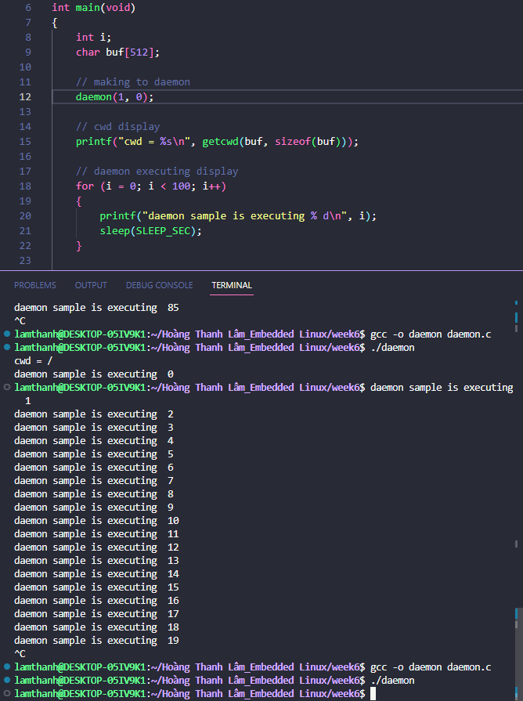

7.6